April 30th, 2025

Rush Creek Creations
600 Perkins Dr Suite 200
Mukwonago, WI 53149

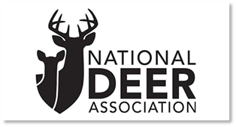

Rush Creek Creations Preferred Vendor Partner National Deer Association
Sales Order Processing

- Rush Creek Creations will send digital images and content to NDA Grass Roots Director Matt Wilkins

- The Fold & Go 10 Gun Stand along with the 5 Gun Wall Rack w/Smart Stock Technology will be uploaded on National Deer Association portal for the 35 Charters to have access.

- For members of the NDA who wish to purchase a gun rack(s) there is a coupon code NDA10 and will receive 10% off the list price.

- To place an order call Rush Creek Creations, toll free 1.844.627.4480 between the hours of 8:00 am – 4:00 pm CST. Or you can visit our site https://rushcreekcreations.com/ Products/Gun Racks, or email us directly sales@rushcreekcreations.com and someone will get back to you quickly.

- All credit card payments are accepted and will be processed at the time of order placement.

- The Purchaser and Grass Roots Director will receive an order acknowledgement that will be used as a paid invoice. This will also include tracking numbers.
Sincerely,

Paul Balfour
Director of Sales
Rush Creek Creations

